# **Name: Abdurrahman Qureshi**

# **Roll No: 210451**

Practical No: 10

1) Write a Python script to Function to calculate the number of upper case and lower case letters in a string

CODE:

def count_upper_lower(string):  
 upper_count = sum(1 for char in string if char.isupper())  
 lower_count = sum(1 for char in string if char.islower())  
 return upper_count, lower_count  
  
input_string = "iLoveGymMommies"  
upper_count, lower_count = count_upper_lower(input_string)  
print("Number of upper case letters:", upper_count)  
print("Number of lower case letters:", lower_count)

OUTPUT:

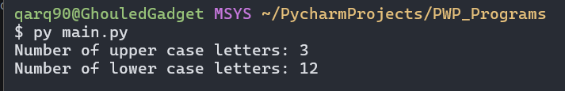

2) Program to generate a random float between 5 and 50 using the random module:

**CODE:**

import random  
  
def generate_random_float():  
 return random.uniform(5, 50)  
  
random_float = generate_random_float()  
print("Random float between 5 and 50:", random_float)

**OUTPUT:**

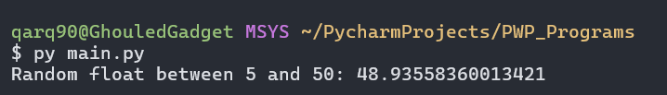

EXTRA QUESTIONS

3) Program demonstrating the use of all math functions.

**CODE:**

import math  
  
*# Constants*radius = 5  
angle_degrees = 45  
  
print("Sine of 45 degrees:", math.sin(math.radians(angle_degrees)))  
print("Cosine of 45 degrees:", math.cos(math.radians(angle_degrees)))  
print("Tangent of 45 degrees:", math.tan(math.radians(angle_degrees)))  
  
print("Exponential of 2:", math.exp(2))  
print("Natural logarithm of 10:", math.log(10))  
print("Base-10 logarithm of 100:", math.log10(100))  
  
print("Square root of 25:", math.sqrt(25))  
print("2 raised to the power of 3:", math.pow(2, 3))  
print("Factorial of 5:", math.factorial(5))  
  
print("Value of pi:", math.pi)  
print("Value of e:", math.e)

**OUTPUT:**

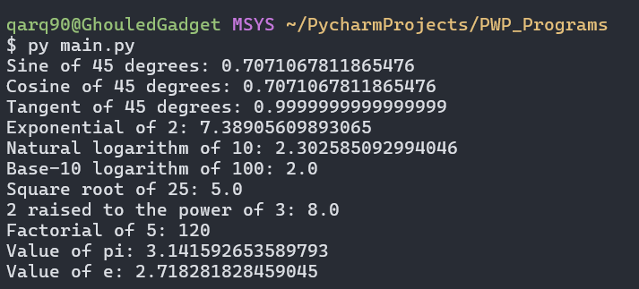

4) Program demonstrating the use of all string functions.

**CODE:**

string = "I Love Gym Mommies"  
  
print("Original string:", string)  
print("Uppercase:", string.upper())  
print("Lowercase:", string.lower())  
print("Capitalized:", string.capitalize())  
print("Title case:", string.title())  
print("Swapped case:", string.swapcase())  
print("Centered (width 20):", string.center(20))  
print("Left-justified (width 20):", string.ljust(20))  
print("Right-justified (width 20):", string.rjust(20))  
print("Count of 'l':", string.count('l'))  
print("Index of 'o':", string.index('o'))  
print("Does the string end with 'World!'?", string.endswith('World!'))  
print("Does the string start with 'Hello'?", string.startswith('Hello'))  
print("Reversed string:", string[::-1])  
print("Split string by comma:", string.split(','))  
print("Joined string with '-' separator:", '-'.join(string))  
print("Stripped string:", string.strip())

**OUTPUT:**

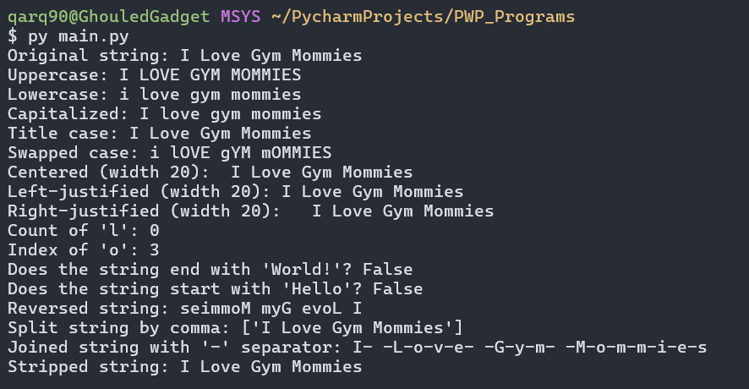

5) Program to search a string and print its position using string function.

**CODE:**

string = "I love Gym Mommies!"  
  
search_string = "Mommies"  
position = string.find(search_string)  
  
if position != -1:  
 print(f"'{search_string}' found at position:", position)  
else:  
 print(f"'{search_string}' not found in the string.")

**OUTPUT:**

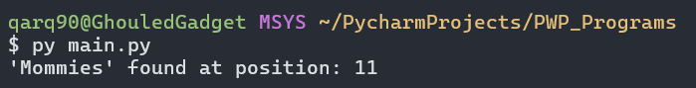

6) Program to replace a string

**CODE:**

string = "I love Gym Mommies!"  
  
old_string = "Gym"  
new_string = "Goth"  
  
replaced_string = string.replace(old_string, new_string)  
print("Original string:", string)  
print("Replaced string:", replaced_string)

**OUTPUT:**

